**DISPLAY ALL FILE NAMES THAT START WITH ‘a’ AND END WITH ‘y’**

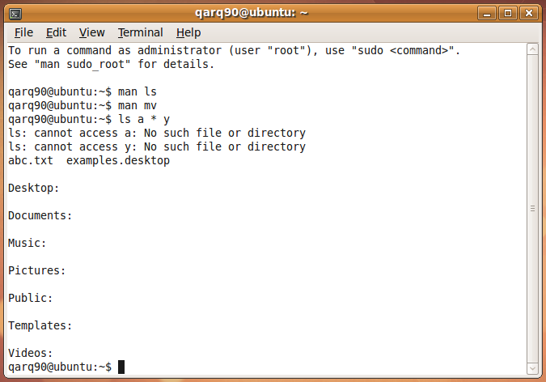

**DISPLAY ALL FILE NAMES THAT START WITH ‘a’ AND END WITH RANGE OF 1 TO 5**

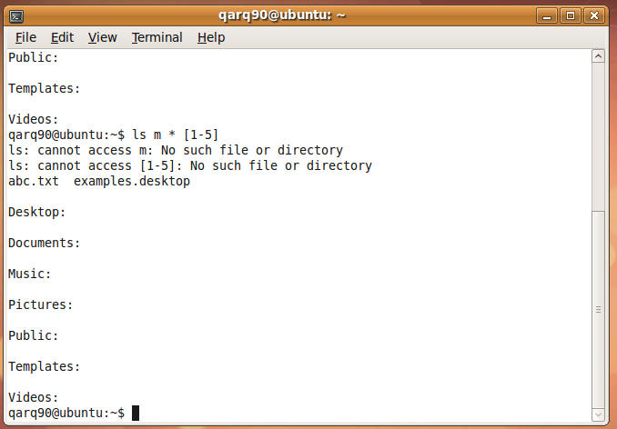

**COPYING THEN RENAMING THEN DELETING COPY** 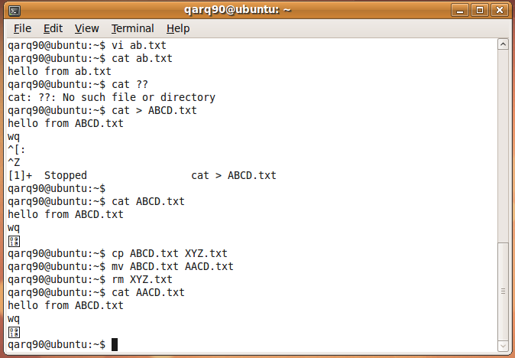

**INODES OF TWO FILES**

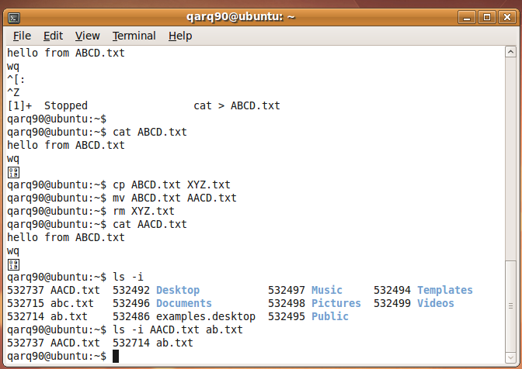

**PERFORMING MULTIPLE COMMANDS ON TWO FILES**

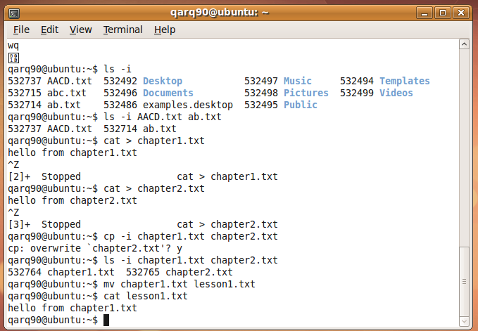

**Ls a * n**

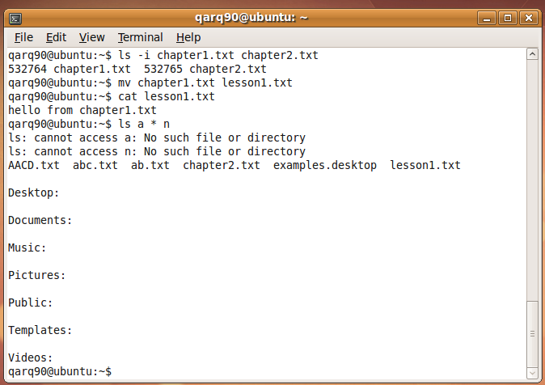

**Ls s**

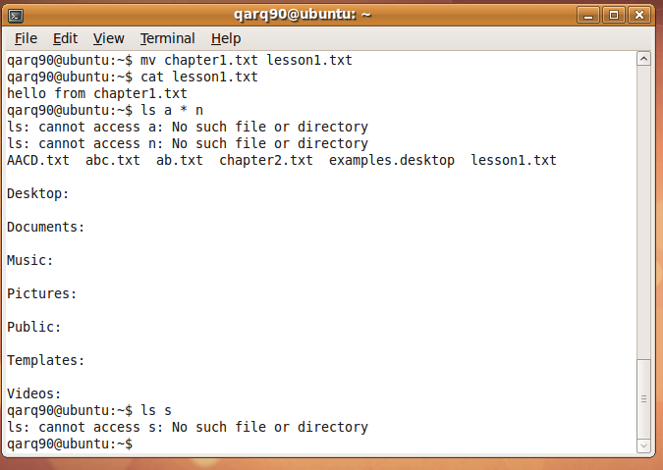

**Cat abc>>>xz**

